Southern Iraqi marshes
Dr. Abdulameer al-Hamdani
Anthropological archaeologist

In their lower courses, the Tigris and Euphrates Rivers have created a vast network of wetlands which comprise a complex of interconnected shallow freshwater lakes, marshes, and seasonally swamped floodplains. However, it is critical to determine whether there are similarities or differences between the ancient and contemporary marshes in respect to the environment and its effect on human social, cultural, and economic adaptation to this environment. Earlier studies demonstrate a tendency to infer that similarity does exist in most aspects, including the ecosystem, types of plants and animals, water sources, input and output water systems, as well as the ways of adaptation and exploitation of environments in the marshes by both ancient and contemporary people.
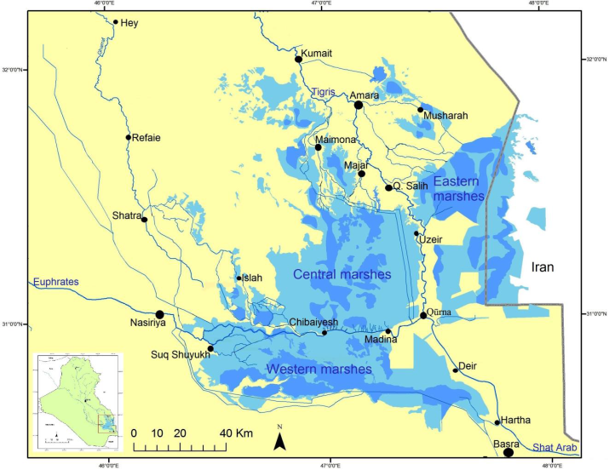
Map 1: Distribution and locations of seasonal (light blue) and permanent (dark blue) marshes in southern Iraq
Nevertheless, there have been some environmental changes, both natural and anthropogenic, which have affected this environment. From the 1970s onwards, the Ba’ath regime in Iraq built earthen dikes, embankments, and sluices to drain areas at the edges of the marshes in order to extract oil. In addition, the water flowing down the Tigris and Euphrates was impacted by the dams on the Tigris and the Euphrates in Turkey and Syria, new irrigation projects constructed since the 1980s, and drainage on the fringes of the marshes for agricultural purposes. As a result, the marshes shrank, and some of the water became salty and polluted. In the 1990s, for political reasons, Saddam Hussein’s regime started a campaign to dry the marshes. A few days after the end of the second Gulf war in February 1991, uprisings against the Iraqi regime broke out both in southern Iraq and in the Kurdistan region in the north. After the insurrections in southern Iraq, some of the rebels took refuge in the marshes. As a result, the Iraqi regime laid siege to the area, and movement in and out of the marshlands was forbidden. Two huge canals were gradually constructed and a number of rivers diverted in a deliberate attempt to drain the marshes so as to make them uninhabitable. By the early 2000s most of the populations had left the marshes. Since 2003, however, the marshes have been partially refilled and almost 70% of those who left the marshes have come back.
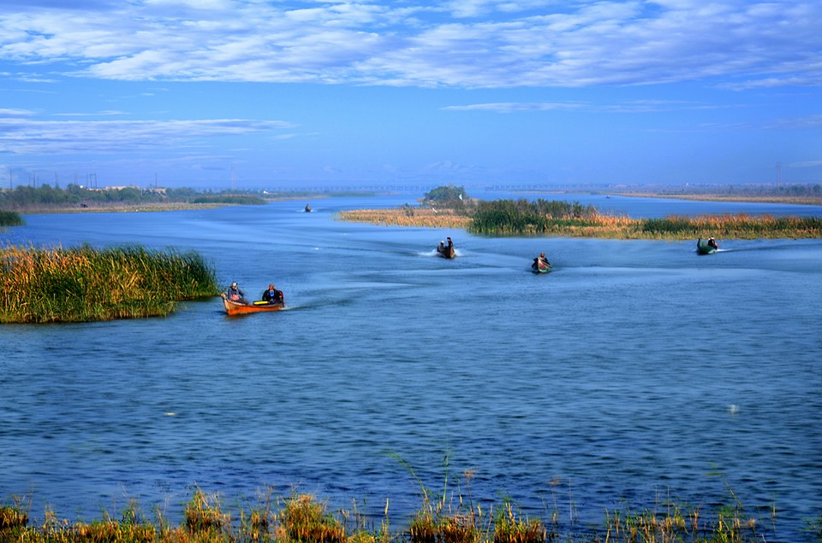
Fig.1: the Euphrates feeds the marshes through series of canals and outlet.
Although the pattern of life in the marshes is changing rapidly, certain aspects appear to have remained remarkably constant over the millennia that separate ancient Mesopotamia from our own time. Archaeological evidence reveals striking parallels in the economic bases of life in the ancient Mesopotamian marshes and contemporary marshes of southern Iraq, such as material culture, transportation, home building, and the weaving of mats and making of baskets. Moreover, there are even some reasons to suppose that the general ecology of the area was little different in ancient times from what it is before the drought of the marshes in 1990s. Despite all of the natural and anthropogenic changes in the marshes described above, the overall structure of the environment of the marshes has not been completely erased or altered. The connection between modern marsh dwellers before the drainage of the marshes during the 1990s and the people of ancient Mesopotamian clearly exist. Both the ecological setting and the use of the same methods and ways of life remain largely unchanged. Agriculture and irrigation practices, materials and methods of house construction, boat building, and textile and food production have experienced little change. Thus, environmental and anthropogenic aspects of the marshes can be used to compare the past and present of human adaptation and exploitation of the marshes; one can also examine the human behavior that is associated with the various environments within the marshes.
Human populations: Genetics, language, religion, and ethnicity
The people of the contemporary marshes of southern Iraq and the people of the ancient Mesopotamian marshes live in very similar ecological settings, use the same methods and tools, and have similar ways of life best seen in their agricultural and irrigation practices, materials and method of house construction, boat building, and textile and food production. Modern villagers in southern Iraq and the ancient Mesopotamian population had adapted in a similar fashion: both used the same locally available raw materials to make similar artifacts, tools, houses, and objects.
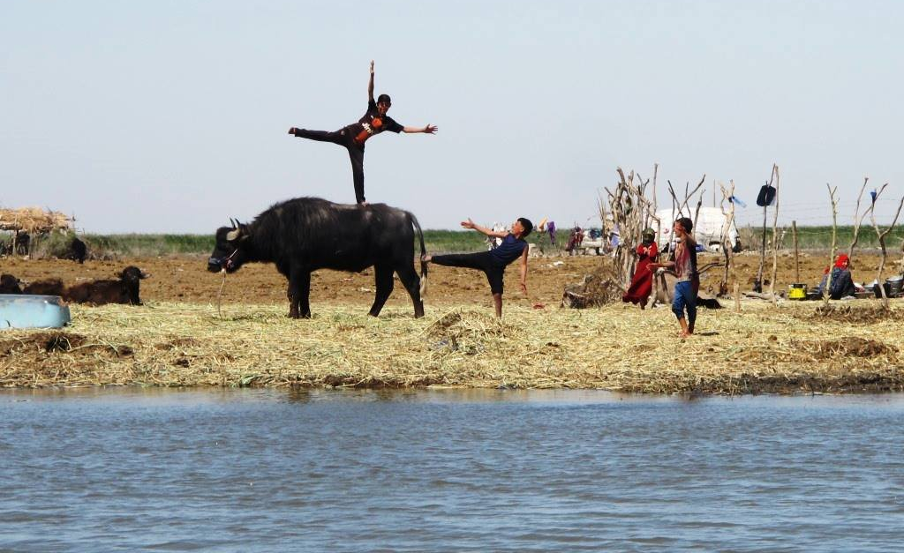
Fig. 2: Water-buffalo and cows are the major economic animals in the marshes
People living in the marshes today may or may not be the direct descendants of the people of the ancient Sealand dynasties in southern Mesopotamia. However, a new survey of Y-chromosome and mtDNA variation of people in the marshes of southern Iraq in comparison with human remains from archaeological sites of southern Iraq shows that they are likely descendants of the ancient Mesopotamians, who themselves were most likely indigenous to southern Iraq.
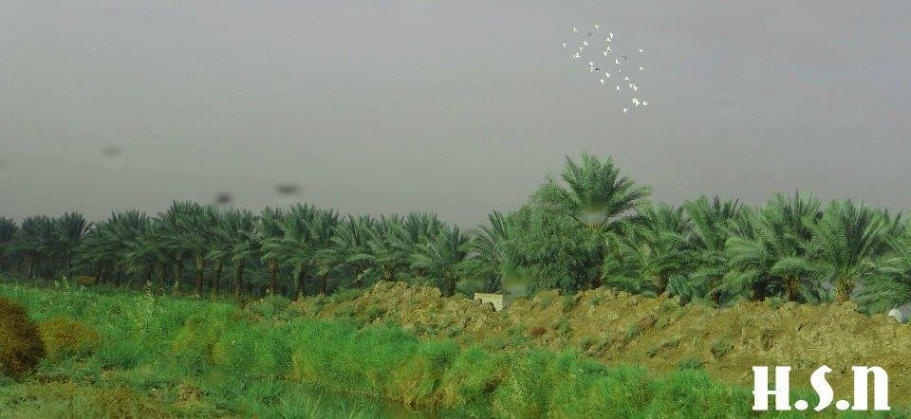
Fig. 3: Date-palm orchards are present in the marshes
The two populations, the ancient Mesopotamians and the contemporary dwellers of the marshes of southern Iraq, follow different religious faiths and culture, and there is some cultural discontinuity between the two societies. Nevertheless, they both live lifestyles that are embedded in this environment in terms of economic resources and social adaptation. For instance, the decisions of whether they are going fishing or hunting, how to build a platform of reed and mud as an artificial island, ways and methods of taming the environment, and what materials that they use to build their houses out of are similar. Moreover, the way of life in the marshes of southern Iraq is considered by scholars to be one of the oldest cultures, and for centuries their self-sufficient way of life has hardly changed.
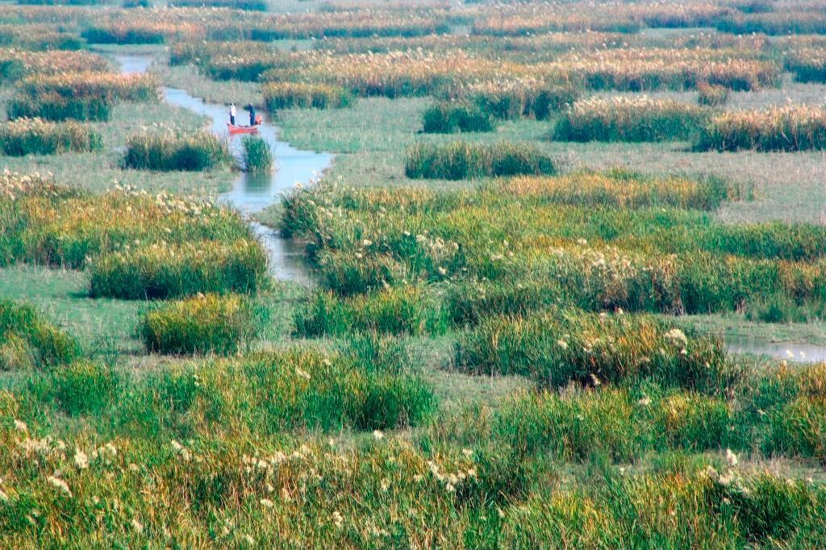
Fig. 4: The Marshes have thick forests of reed, Papyrus, sedge, and other plants
The physical geography and environments of the contemporary marshes
The marshes of southern Iraq are a vast network of wetlands created by the Tigris and Euphrates Rivers. Covering nearly 20,000 square miles, they are considered as one of the largest in the world and the most extensive wetland ecosystem in West Asia. They are located between and alongside the lower courses and basins of the Tigris and Euphrates (30° to 33° N, 45° to 48° E) (Map 1); they lie at an elevation near sea level to approximately 30 m above sea level. In the flood season when the water level in the Tigris and Euphrates is high, about 4,000 square miles are inundated and become connected into one body of water bordered by shallower parts of the marshes. When the water subsides, these shallow marshes become dry land, and the original water body becomes a marsh, with large permanent lakes. The size of the permanent marshes is no more than three-quarters of the marshes at times of flood.
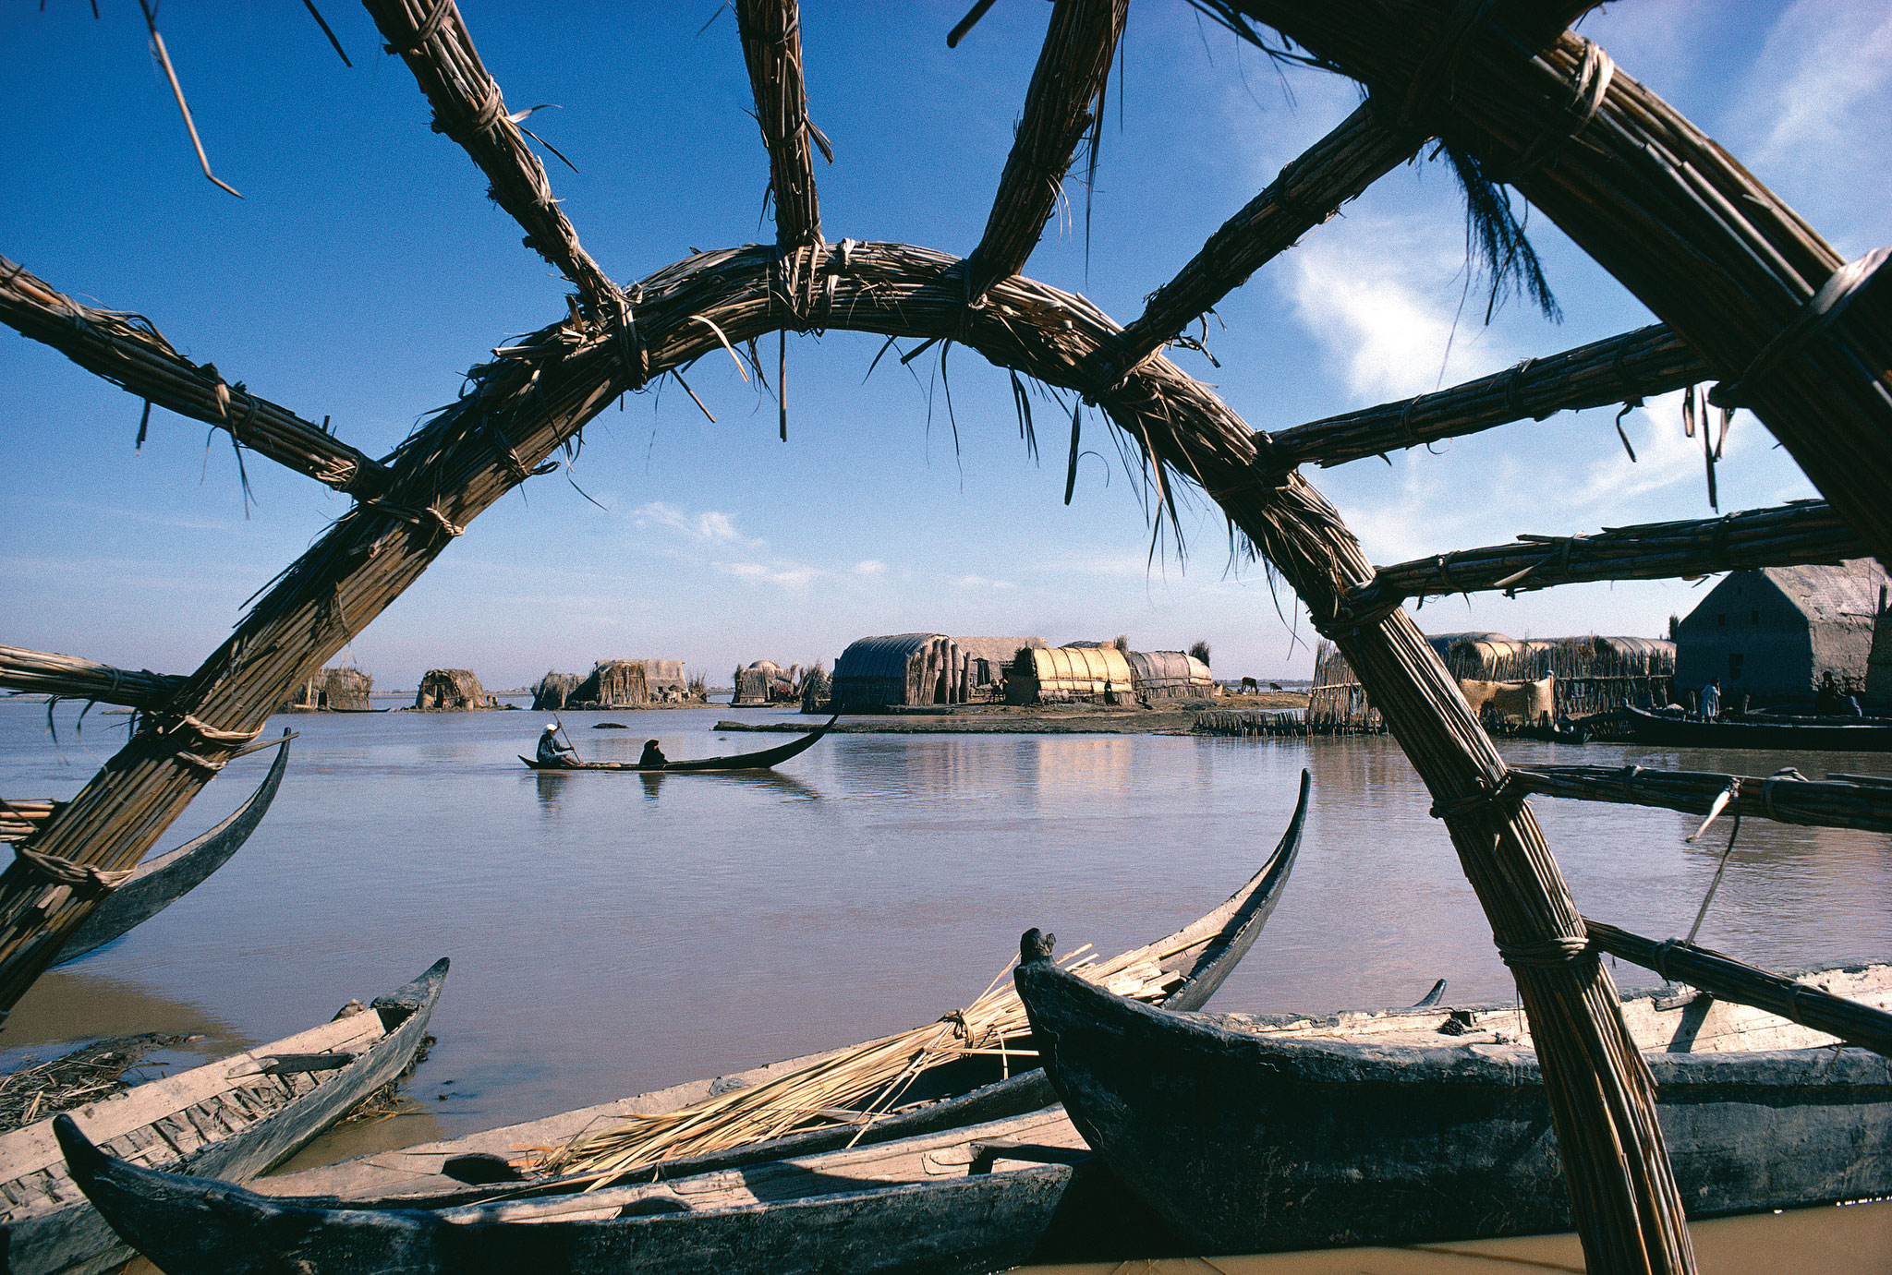
Fig. 5: Dwelling in the marshes made of reed and situated on top of artificial islands (Chibaiyesh).
These marshes eventually drain south-eastwards into the Arab-Persian Gulf. The two rivers pass through the marshes and emerge from the marshes to form the Shatt Al-Arab. The rivers and their unified course are what bring the marshes’ water into the Gulf.
Water level in the marshes reaches its maximum in early spring (March through May) at four meters above the bottom of the marshes and then falls by as much as two meters or little less during the hot dry summer (August and September). By August, some temporary marshes are covered with a growth of sedges and grass and ready to welcome the herds of sheep that take advantage of the pasturage afforded. The waters reach their lowest point in September and October. At this time of the year, the marshes are turned into part marsh, part lake, and part dry land. In November the water level rises slightly, and, with the rainy season in late December or early January, sudden transient floods may occur. The average depth of water in the main marshes during the flood season was about 1.0-1.5 m (3.2-4.9 ft.) and the maximum about 2.0-3.5 m (6.5-11.4 ft.), although a depth of approximately 6 m (20 ft.) has been recorded in Hawr al-Huwaiza. People use various ways of observing the depth of the water, one of which is to look to the traces that water leaves on the reeds as it increases and decreases. The other is to use a long wooden stick to move boats as well as to measure the depth. The measurement unit is an adult's arm, which is almost a half meter. The intensive network of water passages and linkages within the marshes serve as pathways and routes for transportation and communication.
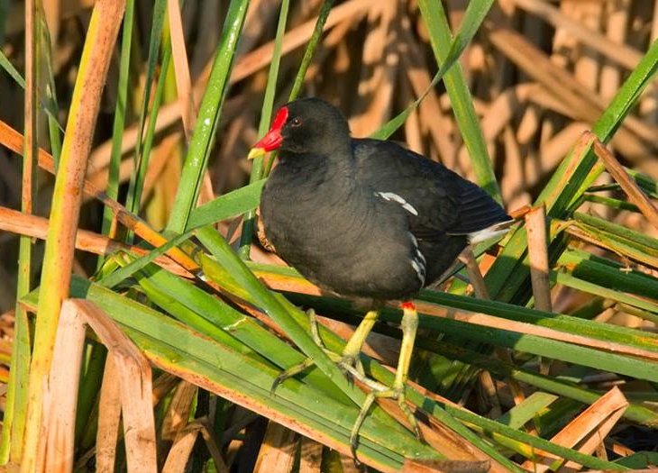
Fig.6: Migrated birds stop in the marshes in their winter journey from Siberia to Africa
Except in the deep clear water, the marshes are thickly covered with clumps of reeds, papyrus, bushes, water weeds, and floating aquatic plants, which can grow vigorously in the freshwater. Many animals inhabit this rich environment, including cattle, water-buffalo, wild boar (Sus scrofa jerus), foxes, dogs, wild cats, weasel, otters, dogfish sharks, snakes, turtles, and porcupines. Marshes are also the permanent habitat for millions of birds and a flyway for millions more migrating between Siberia and Africa They are crucial as incubators for fish and invertebrates. Iraq’s marshes, therefore, play a vital role in the maintenance of biodiversity in Iraq and the Middle East, primarily because of their large size, the richness and diversity of their aquatic vegetation and birds and their isolation from other comparable systems.
Climate
The characteristic feature of the climate in the marshes is a long dry summer, with an air temperature often exceeding 115°F during July and August and probably much higher on the ground during September. As in all semi-arid regions, the range in temperature is wide. Although 115°F is normal in the marshes during the summer, the highest recorded temperature was 129°F during July 1946. On the other hand, frost is often experienced in the cold season, the minimum recorded temperature being 40 °F in January, which can seem bitterly cold. Cold winds sweeping down from the Iranian plateau make the atmosphere of the marshes cold.
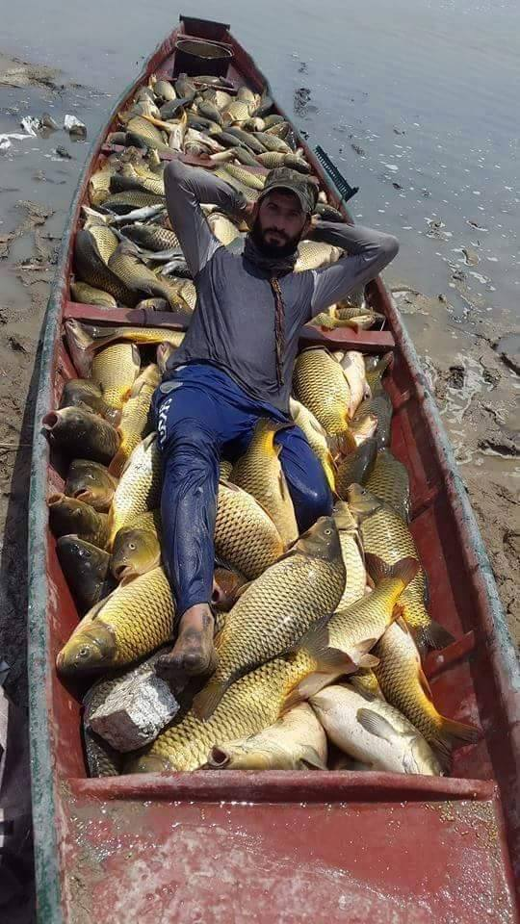
Fig.7: Fish is main food resource in the marshes
During August and September, the date-ripening season, the wind comes from the south, bringing with it a moist atmosphere. The normal speed of the wind rarely exceeds three miles per hour, although sudden gales are not unknown. The rainy season begins in November, reaching its maximum in December and January. The average amount of rain in the marshes is 1.08 cm, and is restricted to autumn, winter and early spring. Except in years when the rain starts late, or is below the average, little falls after the middle of April. Hail is rarely encountered in these parts. Snow has never been recorded, but some small canals, streams, and wetlands in the marshes can freeze in early morning and melt at mid-morning. The maximum relative humidity is in the range of 46-48% in summer and 70-80% in winter. Evaporation is very high from free water surfaces and irrigated land, often exceeding 16 times the rainfall.
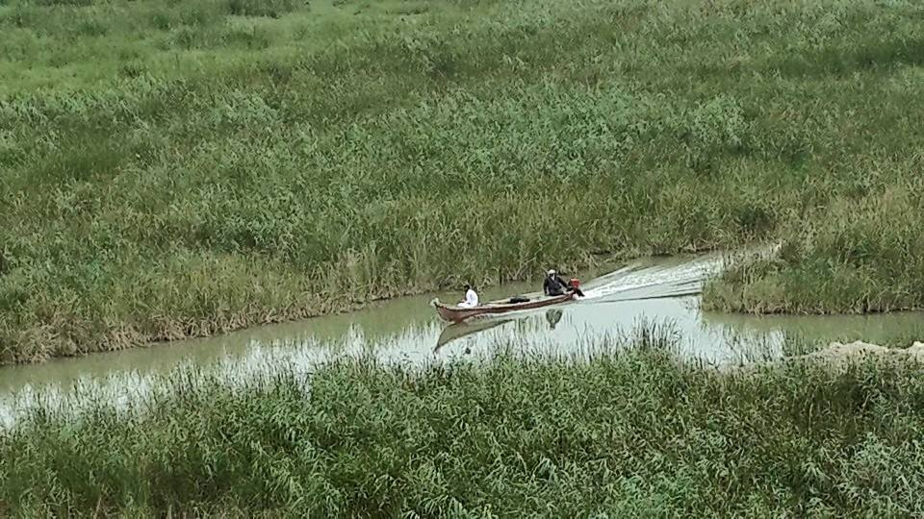
Fig. 8: Boat is the only way of transportation in the marshes through water-passages
Major Marsh areas in southern Iraq
Southern Iraq has three great marshy areas: the eastern marshes, the central marshes, and the western marshes. The eastern marshes lie east of the Tigris; most of them are located in Iraq and take water from the overflow and dispersal of the Tigris and its distributaries of al-Musharra. and al-Ka.la. A portion of the eastern marshes is located in Iran known as Hawr Al-U.aim and is fed by the Karkheh River. These marshes are divided into deep permanent and shallow seasonal types, and are separated by networks of canals and rivers, and sometimes strips of dry land.
The central marshes lie between the Tigris in the east and the Euphrates in the south, between the town of al-Qurna in the south, the city of Amara in the north, and the towns of Shatra and Isla. at the lower reaches of Shatt al-Gharraf in the west. They get water from the Tigris and its distributaries, the Shatt al-Maimunah, Shatt al-Betaira and Majar-al-Kabeer south of Amara, as well as from Shatt al-Gharraf and its distributaries south of al-Shatra. Like the eastern marshes, the central marshes are separated from each other by canals and agricultural fields that are located along the Tigris and the Shatt al-Gharraf and their distributers. 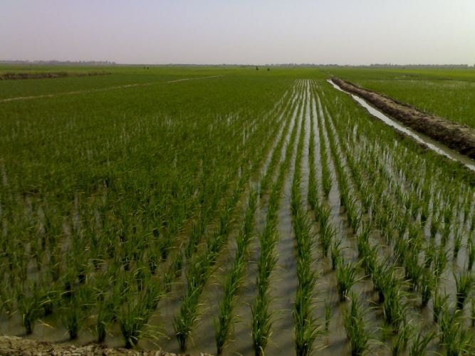
Fig. 9: Rice is another food source in the marshes
The western marshes are located south of the Euphrates around Hawr al-Hammar, and take water primarily from the Euphrates below the city of Nasiriya where numerous canals disperse water gradually into Hawr al-Hammar and thence into the Shatt al-Arab by the channel of Qarmat Ali a few miles above Basra. They take water from the central marshes during the spring flood. The western marshes are bordered by Nasiriya on the west, the Shatt al-Arab on the east and the southern desert on the south. Unlike the eastern and central marshes, these marshes are connected to each other, and become almost one water body during the flood season. Some patches of land in or beyond the southern edge of Hawr al-Hammar have a rich growth of grass, which are used as sheep pastures.

